JASON T. EVANS
LIEUTENANT GENERAL, USA (ret)
Executive Leadership I Talent Management I Human Capital Strategy

Mobile: 571-243-0497
Email: jte21@me.com
linkedin.com/in/lt-gen-jason-t-evans

Jason is an accomplished strategic leader who is passionate about collaborating with people in complex organizations to achieve growth and success. He most recently served as Tennessee State University's Chief Operating Officer. He was selected to serve as the Army's first Deputy Chief of Staff, G-9 (Army's Chief Installations Officer), he provided senior executive leadership for 280 experienced professionals responsible for policy integration for 141 Army Camps, Posts, and Stations worldwide and budget management for the Army's Installation Enterprise investments over $18B. He is currently the President/CEO of Jason T. Evans Enterprise Consulting and a joint partner with Evans Alexander LLC.

Executive Leadership: Selected multiple times to lead Army strategic-level human resources organizations and other complex organizations at the corporate level ranging in size from 250 to over 3,000 people, overseeing budget management of hundreds of millions of dollars to over $18B. He has been a coach, and mentor to hundreds of executives and the rank in file. In his current capacity, he provides senior executive leadership consulting and expertise for strategic planning, leader development, team building, leadership philosophy, program management, operations management, human resources management, and human capital strategies. During, his culminating assignment as the Army Chief Installations Officer, he provided senior leadership oversight for the Army's infrastructure investments, Housing/ Barracks, Installation IT business systems, water and energy resiliency/ security, and Soldier and family quality of Life Programs. He also led policy oversight for the Army’s Controls Systems governance, Cybersecurity analytics, and Federal Information Security Management Act compliance.

Talent Management: Selected to serve in multiple key executive-level Army Human Resources positions, Jason's transformational leadership and innovation aided in growing the Army end strength by 28,000 people in less than a year while overseeing all Army Human Resources policies for over 1.1 million Soldiers worldwide. He led the Talent acquisition, professional military education, promotions process, career development, and global assignment/employment of the Army's Officer Corps (~70,000 people), as well as the Army's Enlisted personnel (~400,000). Provided talent management and human resources support for the assignment and deployment of over 150,000 Soldiers in over 140 countries. He also has experience providing Human Resources support and talent management for 300 Army senior executives (Active Duty general officers).

Human Capital Strategy: Provided corporate-level strategies through the effective use of data and analytics that drove the growth of 5 Security and Assistance organizations (2,500 people) ahead of schedule, while growing people capability by 20% (~2,000) in less than 6 months in support of the Korea crisis.

Jason is known for his innovative executive leadership; and ability to cultivate positive work environments while building high-performing teams and collaborative leaders focused on results and growth. He values transparency, collaboration, accountability, and working with people in results-oriented organizations.
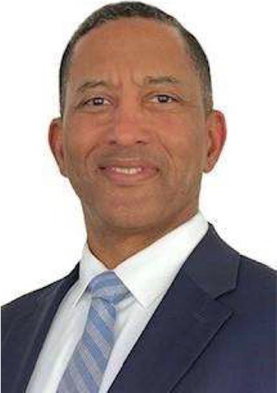

PROFESSIONAL EXPERIENCE
Held Top Secret/Sensitive Compartmented
Information Clearance for 30 plus years.

Chief Installations Officer
(Deputy Chief of Staff G-9(/installations))
Pentagon, Washington, DC

Executive Vice President (Commander)
(Army Human Resources Command)
Fort Knox, KY

Executive Vice President Human Resources Policy
(Director Military Personnel Management)
Pentagon, Washington, DC

Assistant Vice President {Deputy Commander)
{Installation Management Command}
Fort Sam Houston, TX

Assistant Vice President, Human Resources
The Adjutant General, Fort Knox, KY

Senior Executive Assistant & Advisor
(Executive Officer)
Assistant Secretary of the Army
Pentagon, Washington, DC

MULTINATIONAL FORCES- IRAQ
Executive Director Human Resources
(Director, Personnel)
Camp Victory, Iraq

Executive Director (Commander)
Garrison Command, Fort Monroe, VA

OFFICE OF THE CHIEF OF STAFF, ARMY
Deputy Executive Director
General Officer Management Office
Pentagon, Washington, DC

EDUCATION:

Master of National Resource Strategy
National Defense University

Master of Business Administration
Webster University

Bachelor of Business Administration
Bellevue University

Strategic Leadership Development Course
University of North Carolina
Kenan Flagler Business School

